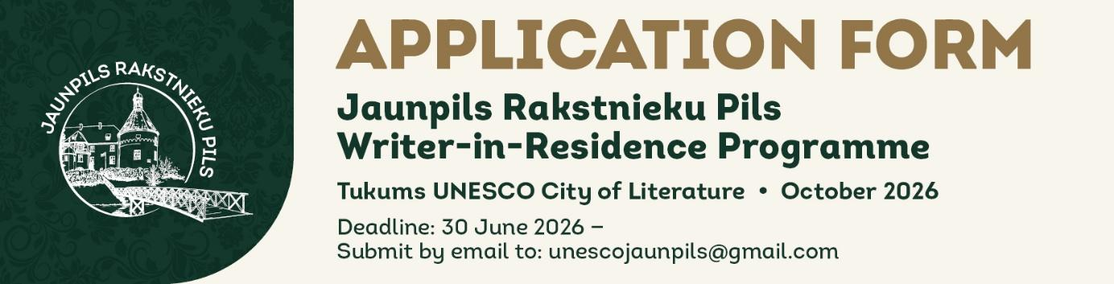
HOW TO COMPLETE THIS FORM Please type your answers directly into this document (click in the shaded fields or after the question text). Save the completed form and email it to unescojaunpils@gmail.com together with any required attachments. The form must be submitted in English. Font: Arial Narrow (or Arial if unavailable). Answers should be concise and honest — there is no advantage to writing the maximum word count if fewer words serve the purpose.
I. PERSONAL DETAILS

First Name |  | Last Name

Date of Birth |  | Nationality

Gender / Preferred pronouns (optional — e.g. she/her, he/him, they/them, or free text)

Home Address (street, city, country, postal code)

Phone (with international dialling code) |  | E-mail address

Website and/or social media profiles (e.g. personal website, Facebook, Instagram, LinkedIn — optional)

Any other information you consider relevant (e.g. medical conditions or access needs the organisers should be aware of — optional)

PREFERRED RESIDENCY PERIOD
Please select one option:
☐ Four-week residency: 1–28 October 2026 (including arrival and departure days)
☐ Two-week residency — first half: 1–15 October 2026 (including arrival and departure days)
☐ Two-week residency — second half: 17–30 October 2026 (including arrival and departure days)
If none of these exact dates work due to flight availability from your country, please note your preferred alternative dates in the field below. Adjustments of a few days may be possible for the four-week period only. For two-week residencies, dates are fixed.

Alternative dates (if applicable) (four-week applicants only — leave blank if the standard dates suit you)

COMPANION
☐ I will reside alone
☐ I will be accompanied by a creative partner /spouse who is also a practising writer (please complete and attach the Companion Application Form)

Please note: children and pets are not permitted in the residency. A companion who is a practising writer and will use the residency for their own creative work is welcome to share the apartment. The scholarship amount (€800 / four weeks or €400 / two weeks) remains unchanged regardless of the number of residents.
III. PROFESSIONAL EXPERIENCE

Overview of your literary work and achievements (max 500 words)

Give a clear and informative summary of your writing career: your genres, themes, significant publications, awards or recognitions, and anything that defines your literary voice. You may write this in the first or third person. Max 500 words.

Educational background (degrees, institutions, fields of study)

CHRONOLOGICAL LIST OF PUBLISHED WORKS

List your published works in reverse chronological order (most recent first). Include: title, genre, publisher, year of publication, and language. Traditional publishing only (no self-publishing). If any of your works have been translated into Latvian, please note this. Add rows as needed.

Title | Genre | Publisher | Year | Language / Notes
If you have more publications, you may add additional rows or attach a separate list.

Please attach a writing sample as a separate file: an excerpt from a published or forthcoming work, 1,500–3,000 words in length. The sample should be in English or Latvian; if the original is in another language, please also include an English translation. The sample may be from the project you plan to work on during the residency, or from another work.

☐ Writing sample attached (file name: ___________________________)
III. CONNECTION AND MOTIVATION

UNESCO CITY OF LITERATURE CONNECTION
In which UNESCO City (or Cities) of Literature do you currently reside and/or work?

Briefly describe your connection to that city and its literary community

REPRESENTATIVE OF YOUR UNESCO CITY OF LITERATURE
If your application is supported by the representative of your local UNESCO City of Literature office, please provide their contact details below. This is not mandatory but will strengthen your application.

Name of the City of Literature representative |  | E-mail / contact details

THE PROJECT

Describe the project you plan to work on during the residency (max 500 words)

Please be specific and realistic. Include: genre, working title (if any), stage of the project (early planning, first draft, revision, etc.), what you hope to achieve during the residency period, and why this particular time and place would support your work. Max 500 words.

WHY JAUNPILS?

Why did you choose to apply to the Jaunpils Writers’ Castle residency in Latvia? (max 500 words)

Tell us about your motivation: what draws you to Latvia, to Tukums and to this specific residency? How does it connect to your literary interests, your project or your broader development as a writer? Max 500 words.

YOUR EXPECTATIONS

What do you hope to gain from this residency? (max 500 words)

Describe your expectations in terms of creative output, professional development, cultural exchange, and engagement with the local literary community. What would make this residency a success for you? Max 500 words.

IV. LIST OF ATTACHMENTS

Please tick all documents included with your application:

☐ Completed Application Form (this document)
☐ Writing sample (1,500–3,000 words, in English or Latvian)
☐ Companion Application Form (if applicable)
☐ Other:(specify) _______________________________________________

V. DECLARATION AND CONSENTS

Please read each statement carefully and tick the box to confirm your agreement. All four declarations are required for your application to be considered.

☐ I confirm that the attached writing sample is entirely my own work and does not infringe any third-party copyright, property rights or moral rights.
☐ I confirm that all information provided in this application form is accurate and complete to the best of my knowledge.
☐ I consent to the Tukums City of Literature processing the personal data I have provided in this form and its attachments for the purposes of administering the Jaunpils Writer-in-Residence Programme — including applicant selection and programme implementation — in accordance with Article 6(1)(a) of Regulation (EU) 2016/679 (GDPR). I understand that I may withdraw this consent at any time by contacting unescojaunpils@gmail.com.
☐ If selected, I agree to the publication of my name on the Tukums City of Literature website and social media profiles (Facebook, Instagram) in connection with the announcement of the residency.
☐ If selected, I agree to share a short excerpt from work created during my residency (a passage, short story, poem or piece of prose) with the Tukums City of Literature for use in communications about the programme.

Full Name |  | Date

As this is a Word document submitted by email, a typed name in the Name field above is accepted in place of a handwritten signature.

Submit your completed application by 30 June 2026 to unescojaunpils@gmail.com. Selected residents will be notified by email in early August 2026.

Tukums UNESCO City of Literature • tukums.lv • unescojaunpils@gmail.com

